June 1, 2026 | Inventory Management System
Project Title Finalization

Overview
The first day of the project is dedicated to defining and finalizing the official project title. A well-defined title sets the scope and direction for the entire development lifecycle. The project title chosen is: Inventory Management System.
Activities Performed
- Brainstormed potential project titles relevant to the domain of stock and warehouse management.
- Discussed with the team and Head of Department (HoD) about the suitability and scope of various titles.
- Evaluated titles based on clarity, relevance, and technical feasibility.
- Finalized the title 'Inventory Management System' after mutual agreement.
- Documented the rationale for the chosen title.
Why This Title?
An Inventory Management System addresses a critical business need — tracking stock levels, orders, sales, and deliveries efficiently. It is widely applicable across retail, warehousing, and manufacturing sectors, making it an impactful and practically relevant project.
Outcome
The project title was formally approved and submitted. This gives a clear identity to the project and helps in scoping the subsequent requirements, modules, and deliverables accordingly.

Expected Deliverable: Approved Project Title — Inventory Management System

June 2, 2026 | Inventory Management System
Requirement Gathering

Overview
Requirement gathering is one of the most critical phases in software development. On this day, all functional and non-functional requirements for the Inventory Management System were identified and documented in the form of a Problem Statement.
Functional Requirements Identified
- User authentication (login/logout with role-based access).
- Add, update, delete, and view inventory items.
- Track stock levels and receive low-stock alerts.
- Generate inventory reports (daily, weekly, monthly).
- Manage supplier and purchase order information.
- Dashboard with real-time stock overview.
Non-Functional Requirements Identified
- System must be secure with encrypted credentials.
- Fast response time (< 2 seconds for all queries).
- User-friendly and responsive UI using React.
- Scalable to handle large product catalogs.
Problem Statement
Manual inventory tracking leads to stock discrepancies, delayed order fulfillment, and poor decision-making. The Inventory Management System aims to digitize and automate inventory operations, reducing human error and improving operational efficiency.

Expected Deliverable: Expected Deliverable: Problem Statement Document

June 3, 2026 | Inventory Management System
Objective Definition

Overview
After gathering requirements, the next step is to define clear, measurable, and achievable project objectives. These objectives guide the development process and serve as success criteria for the project.
Primary Objectives
- Develop a full-stack Inventory Management System using React (frontend) and Spring Boot (backend).
- Implement CRUD operations for inventory items including product name, quantity, price, and category.
- Build a secure authentication system with JWT-based login for Admin and Staff roles.
- Create a real-time dashboard showing total stock, low stock alerts, and recent activity.
- Integrate a RESTful API layer for seamless frontend-backend communication.
Secondary Objectives
- Enable search and filter functionality for quick item lookup.
- Generate printable inventory reports.
- Provide a responsive UI accessible on both desktop and mobile browsers.
Technical Stack Defined
- Frontend: React.js with Tailwind CSS / Bootstrap.
- Backend: Spring Boot (Java) with REST APIs.
- Database: MySQL with JPA/Hibernate.
- Tools: Postman (API testing), GitHub (version control), IntelliJ IDEA / VS Code.

Expected Deliverable: Expected Deliverable: Project Objectives Document

June 4, 2026 | Inventory Management System
User & Module Identification

Overview
This phase involves identifying all the users (actors) of the system and the functional modules the system will be divided into. This helps in designing the architecture and planning the development workflow.
User Roles Identified
- Admin — Full access to all modules including user management, reports, and settings.
- Staff / Inventory Manager — Can add, update, and view inventory items; cannot delete records or manage users.
- Viewer (Read-Only) — Can view inventory and generate reports but cannot modify data.
Modules Identified
- Authentication Module — Login, logout, session management, and role-based access control.
- Dashboard Module — Summary view of stock levels, recent transactions, and alerts.
- Inventory Module — CRUD operations for products, categories, and stock quantity.
- Supplier Module — Manage supplier details and link them to products.
- Purchase Order Module — Create and track orders from suppliers.
- Reports Module — Generate inventory reports with filters and export options.
- User Management Module — Admin-only panel to add/remove users and assign roles.
Outcome
A comprehensive Module List was created, clearly defining the boundary of the system and what each module is responsible for. This list will be referenced throughout development to ensure all features are implemented.

Expected Deliverable: Expected Deliverable: Module List

June 5, 2026 | Inventory Management System
Use Case Diagram Preparation

Overview
A Use Case Diagram visually represents the interactions between users (actors) and the system (use cases). It provides a high-level overview of system functionality and helps stakeholders understand what the system will do.
Actors in the System
- Admin — Interacts with all system features including user management and reports.
- Staff / Inventory Manager — Manages inventory items, views dashboard, places purchase orders.
- Supplier — Receives purchase orders (external actor).
Key Use Cases Identified
- Login / Logout — All users authenticate using username and password.
- Manage Inventory — Add, edit, delete, and search inventory items (Admin & Staff).
- View Dashboard — See stock summary, alerts, and recent transactions.
- Manage Suppliers — Add and update supplier information (Admin only).
- Place Purchase Order — Create orders linked to suppliers and products.
- Generate Reports — Export inventory data as PDF/Excel with date filters.
- Manage Users — Admin creates, edits, or removes system users.
UML Class Diagram
The UML Class Diagram below shows the system's core classes, their attributes, methods, and relationships such as association, aggregation, and dependency.

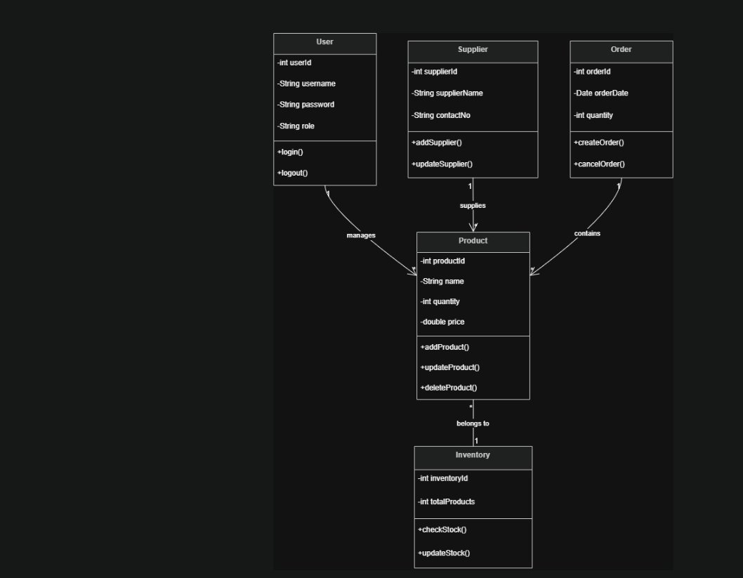
Figure 1: UML Class Diagram — Inventory Management System
Expected Deliverable: Expected Deliverable: Use Case Diagram Submission

June 6, 2026 | Inventory Management System
Database Requirement Analysis

Overview
Database Requirement Analysis involves identifying all the data entities, their attributes, and the relationships between them. This forms the foundation for designing the database schema. The output of this phase is a Table List.
Tables Identified
- users — Stores user credentials and role information (user_id, username, password, role, email, created_at).
- products — Stores inventory item details (product_id, name, description, category_id, unit_price, quantity, supplier_id, created_at).
- categories — Classifies products (category_id, category_name, description).
- suppliers — Stores supplier contact info (supplier_id, name, contact_person, phone, email, address).
- purchase_orders — Tracks orders placed to suppliers (order_id, supplier_id, order_date, status, total_amount).
- order_items — Line items in each purchase order (item_id, order_id, product_id, quantity, unit_price).
- transactions — Logs every stock-in and stock-out event (transaction_id, product_id, type, quantity, date, user_id).
Key Relationships
- A Product belongs to one Category; a Category can have many Products.
- A Product is supplied by one Supplier; a Supplier can supply many Products.
- A Purchase Order contains many Order Items; each Order Item refers to one Product.
- Each Transaction is performed by one User and linked to one Product.
Outcome
A detailed Table List was produced documenting all database tables, their columns, data types, primary keys, and foreign key relationships. This will be used in the next phase to design the ER Diagram.

Expected Deliverable: Expected Deliverable: Table List

June 7, 2026 | Inventory Management System
ER Diagram Design

Overview
An Entity-Relationship (ER) Diagram is a visual representation of the database structure. It shows entities (tables), their attributes, and the relationships between them using standard notation. Designing the ER diagram is a crucial step before writing SQL queries.
Entities and Their Primary Keys
- User (user_id) — Central actor performing all system operations.
- Inventory (inventory_id) — Tracks location and total stock of products.
- Product (product_id) — Core entity representing an inventory item.
- Supplier (supplier_id) — External entity providing stock to the inventory.
- Order (order_id) — Represents a stock replenishment request with date, quantity, and status.
- Report (report_id) — Generated reports including type and date.
Relationships
- User — Manages → Inventory (1 to M)
- Inventory — Contains → Product (1 to M)
- User — Creates → Order (1 to M)
- Inventory — Generates → Order (1 to M)
- Product — Includes → Report (M to N)
ER Diagram
The ER Diagram below was created using standard Chen notation, clearly marking entities, attributes, and relationship diamonds with cardinality (1, M, N).

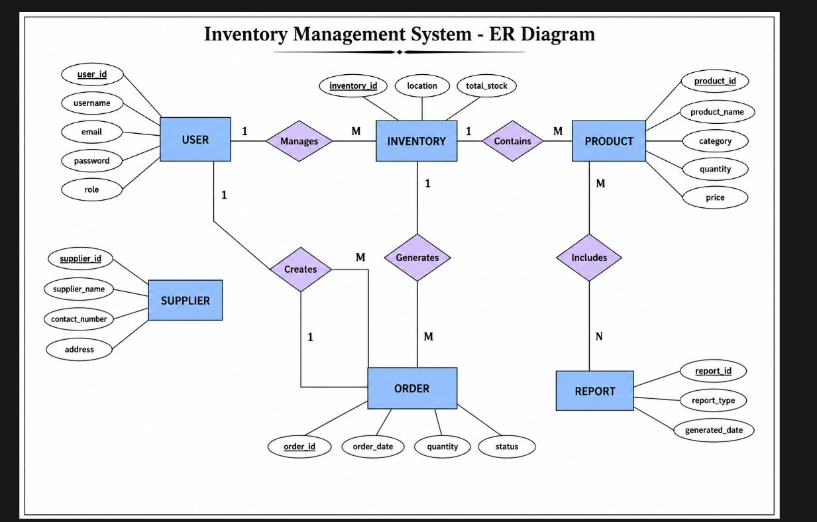
Figure 2: ER Diagram — Inventory Management System
Expected Deliverable: Expected Deliverable: ER Diagram

June 8, 2026 | Inventory Management System
Database Schema Creation

Overview
Based on the ER Diagram designed on Jun-07, the physical database schema was created using SQL (Structured Query Language). This involves writing CREATE TABLE statements with proper data types, constraints, primary keys, and foreign keys for MySQL.
Key SQL Tables Created
- CREATE TABLE users — Includes user_id (PK), username (UNIQUE, NOT NULL), password_hash, role ENUM('ADMIN','STAFF','VIEWER'), email, created_at TIMESTAMP.
- CREATE TABLE categories — Includes category_id (PK), category_name (NOT NULL), description TEXT.
- CREATE TABLE suppliers — Includes supplier_id (PK), name, contact_person, phone, email, address TEXT.
- CREATE TABLE products — Includes product_id (PK), name, description, unit_price DECIMAL(10,2), quantity INT DEFAULT 0, category_id (FK), supplier_id (FK).
- CREATE TABLE purchase_orders — Includes order_id (PK), supplier_id (FK), order_date, status ENUM('PENDING','RECEIVED','CANCELLED'), total_amount DECIMAL.
- CREATE TABLE order_items — Includes item_id (PK), order_id (FK), product_id (FK), quantity INT, unit_price DECIMAL.
- CREATE TABLE transactions — Includes transaction_id (PK), product_id (FK), user_id (FK), type ENUM('IN','OUT'), quantity INT, transaction_date TIMESTAMP.
Constraints Applied
- Primary Keys (PK) defined on all ID columns with AUTO_INCREMENT.
- Foreign Keys (FK) with ON DELETE RESTRICT to protect referential integrity.
- NOT NULL constraints on mandatory fields to avoid incomplete records.
- UNIQUE constraint on username and email in the users table.
Outcome
A complete and validated SQL Schema file (schema.sql) was created and tested on a local MySQL instance. All tables were successfully created and relationships verified. This schema will be used as the foundation for backend development with Spring Boot and JPA.

Expected Deliverable: Expected Deliverable: SQL Schema (schema.sql)

